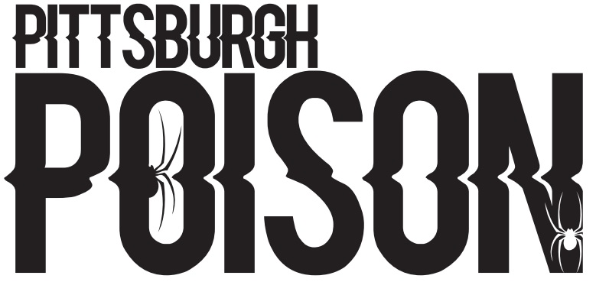

40
42
46
54
55
56
58
63
64
65
67
200
201
DART FROGS

PRACTICE INFO
All teams will practice once/week in the summer. In addition to team practice, athletes will be assigned to a tumbling class, tricks class and stretching/conditioning class (skills). During the school year teams will practice twice/week and will have skills. School year schedule will be posted by August 1st.
Summer Practice | Mondays 8:30-10:00pm
Summer Skills | Schedule will be emailed
School Year Practice | Two days/week TBA
Choreography | July 15-18

COMPETITION SCHEDULE
Date | Event | Location
November 12th | Americheer | Dayton, OH
December 3rd-4th | WSF | Louisville, KY
December 11th | Elite | Pittsburgh, PA
January 22nd | CCC Hard Rockin Nationals | Erie, PA
February 19th | CCC Red Hot | Slippery Rock, PA
March 4th-5th | Stage 8 | Nashville, TN
March 18th-19th | CSG Dance Grand Nationals | Schaumberg, IL
April 1st-2nd | Dance 1st | Dayton, OH

*This team will compete to earn a bid to the Dance Worlds. The Dance Worlds will be held April 22-24, 2023 in Orlando, Florida.
TEAM INTRO- Wednesday June 15th 5:30pm. Athletes and parents will attend. Athletes wear practice wear. If time permits, we will practice.

June Tuition- $100 due at team intro. Crossovers do not pay extra in June. Cash or check only.

Summer practice schedule will begin June 20th.

