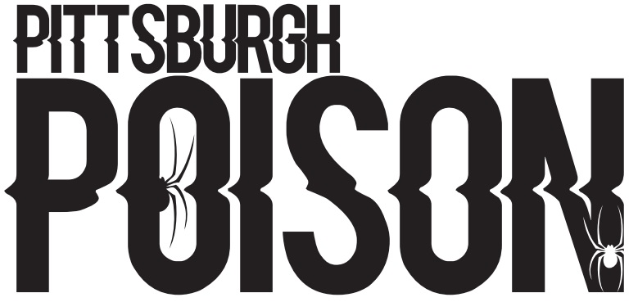
POISON ARROWS
P- Primary Team, S- Secondary Team, SS- Third Team. You must accept your Primary team in order to crossover.

91 | S
100 | S
101 | S
106
110
113 | S
114 | S
115 | S
118 | S
122 | S
123
127 | P
129 | S
132 | S
134 | S
137 | P
141 | S
204 | S
90 | provisionary
95 | provisionary
97 | provisionary
138 | provisionary

*Provisionary members will continue the tryout process over the next few weeks while practicing with the team. Status will be finalized prior to choreography.

PRACTICE INFO
All teams will practice once/week in the summer. In addition to team practice, athletes will be assigned to a tumbling class, stunt positions class and stretching/conditioning class (skills). During the school year teams will practice twice/week and will have skills. School year schedule will be posted by August 1st.
Summer Practice | Thursdays 5:00-6:30pm
Summer Skills | Schedule will be emailed
School Year Practice | Two days/week TBA
Choreography | July 24-29

COMPETITION SCHEDULE
Date | Event | Location
November 12th | Americheer | Dayton, OH
November 19th-20th | Allstar Challenge | Kalahari- Sandusky, OH
December 3rd-4th | WSF | Louisville, KY
December 11th | Elite | Pittsburgh, PA
January 21st | CCC Winter Blast | Erie, PA
February 4th | Aloha | Moon, PA
February 19th | CCC Red Hot | Slippery Rock, PA
March 25th-26th | Cheerpower | Columbus, OH
*This team will compete to earn a bid to the D2 Summit. The D2 Summit will be held May 5-7, 2023 in Orlando, Florida.
TEAM INTRO- Wednesday June 15th 7:30pm. Athletes and parents will attend. Athletes wear practice wear. If time permits, we will practice.

June Tuition- $100 due at team intro. Crossovers do not pay extra in June. Cash or check only.

Summer practice schedule will begin June 20th.

