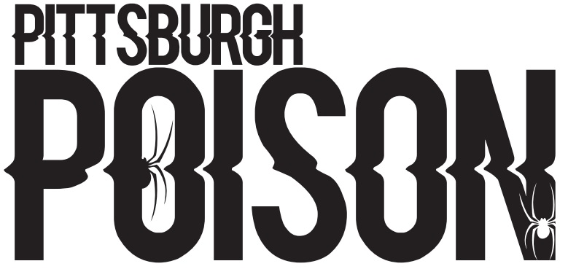
ALL STAR CHEER AND DANCE TEAM TRYOUT INFORMATION
Thank you for your interest in Pittsburgh Poison! We are celebrating 19 years of excellence as we head into our 20th season! Pittsburgh Poison has a World Class Staff that you will be sure to love. We pride ourselves on maximizing the potential of each of our athletes, while developing their character and self-esteem. We believe in hard work and dedication. We teach our athletes that commitment and preparation are essential in achieving success. We build true relationships with our athletes and their families. We believe that everyone involved will feel at home at Poison. And while we are focused on the goals of our program, we believe that having fun and enjoying cheer and dance is a must!
We are proud to say that our staff is highly respected. The Pittsburgh Poison coaching staff does choreography in house for many of our teams. We also work with some of the country’s top choreographers. This combination gives us a competitive edge. We are able to create routines that showcase the true strengths of our athletes. Our staff has done choreography for cheer and dance teams around the country ranging in age from elementary through college. Our staff also has local, National and International judging experience. Our judging experience gives us yet another competitive edge.
We cannot wait to get started with our new teams. Please review the attached information. Thank you for choosing Pittsburgh Poison!

TRYOUT PROCESS
- Pre- Tryout Parent Meeting- Tuesday May 31st, 7:30pm
Wednesday June 1st |  | Thursday June 2nd
5:30-7:00 | Hip Hop Birth Years 2019-2012 | 5:30-7:00 | Cheer Birth Years 2017-2013
7:30-9:30 | Hip Hop Birth Years 6/1/2003-2013 | 7:30-9:30 | Cheer Birth Years 6/1/2003-2012
- Tryouts- part 1-Athletes will attend according to their birth year

- Tryouts- Part 2-These times are tentative. More groups will be added if needed. Groups will be posted on the website after placements part 1.
Friday June 3rd |  | Saturday June 4th
6:30-9:00 | Hip Hop- Junior/Senior Hip Hop | 10:00-11:00am | Cheer Group 1
 |  | 11:00-12:00pm | Cheer Group 2
 |  | 12:00-1:00pm | Cheer Group 3
 |  | 1:00-2:00pm | Cheer Group 4
 |  | 2:00-3:00pm | Cheer Group 5
 |  | 3:00-4:00pm | Hip Hop Group 1
 |  | 4:00-5:00 | Hip Hop Group 2

- Tryouts- Part 3- Sunday June 5th- This will be only for Junior/Senior teams if necessary.
- Results- Results will be posted on the placements page by Friday June 10th at 8pm. Please understand that Pittsburgh Poison reserves the right to move athletes from team to team throughout the season. More information will be given at the pre-tryout meeting.
- Parent Meeting and Team intros- Monday June 13th and Tuesday June 14th. Times will be posted with tryout results. First payment is due at this time.
- Practices- Practices will begin on Wednesday June 15th

WHAT TO WEAR

Female athletes are to wear a black tank or sports bra and black shorts or leggings. Male athletes are to wear a black T shirt or tank and black shorts. Hair must be pulled in a high ponytail or high bun with no bangs or flyaways. Cheer athletes must wear a bow. Cheer athletes are to wear cheer shoes or tennis shoes. Hip Hop athletes can wear any type of tennis shoe/high top. Shoes should not have a thick sole.

TEAM PLACEMENT INFORMATION
Our staff will evaluate the athletes throughout the tryout process. The staff will meet extensively to select our 2022-2023 teams. We will form teams that will have the best possible chance for success. Cheer athletes will be placed according to age and skill level. We are expecting to have between 4-6 cheer teams. Dance placements are not as cut and dry as cheer, as there are no required skills per level. Pittsburgh Poison will form teams with dancers that complement each other. We will consider skill, performance, endurance, physical strength, size and age. We are expecting to have between 6-9 hip hop teams! We plan to offer pom teams this year. The pom teams will be half year teams. Tryouts will be held in late fall. Details will be given at a later date. All of our teams will be set up for success!
PRIVATE TRYOUTS
If you are unable to attend tryouts, email PittsburghPoison@comcast.net to schedule a private tryout.
SUMMER PRACTICES
Summer practices will begin Wednesday June 15th. Teams will practice on weekdays only throughout summer. During the school year teams will practice 1 day during the week and one day on the weekend.
ADDITIONAL INFORMATION
- No-Cut Policy- Pittsburgh Poison has a place for everyone! We have a no cut policy for our tiny-senior teams. However, some athletes may be placed as alternates. This does not apply to the open teams.
- Cheer/Dance Cross-over Athletes- Athletes are permitted to participate in both cheer and dance. Cheer/Dance athletes will receive discounted tuition but will pay full price for competition fees.
- Cross-overs- Athletes are permitted to participate on more than one cheer team and or more than one hip hop team. The coaches will place athletes on a primary team. Athletes must accept their spot on their primary team in order to participate on their secondary team. If an athlete does not choose to accept the spot on the secondary team, they must let us know by Thursday, June 30th. Athletes that are on more than one team will have additional expenses.
- Competition Season- Regular competition season will run November-April. Teams that qualify for Worlds (junior/senior dance teams) will compete in Florida in April. Teams that qualify for D2 Summit (select cheer teams) will compete in Florida in May. Competition schedule will be discussed at the post tryout meeting.
COMMITMENT
Time Commitment-We are a small gym, but we are a competitive gym. We have high expectations. Practices are mandatory. Most teams will practice twice per week. Additional practices may be added as competition season approaches. All teams will have an added practice during competition week. Worlds and Summit teams will practice several more days per week in April and May (Summit only). All Worlds and Summit practices are mandatory!
Absences-All excused absences must have a 2 week notice with approval from coaches. We will excuse absences for summer vacations, school activities for a grade, sickness, etc. Practices during the week of a competition are mandatory. Excessive unexcused absences will result in suspension/removal from the team.
Financial Commitment- Please keep in mind that we are a small business. We rely on your timely payments in order to make bills, pay competition fees, etc. Late payments could result in suspension/removal from the team.
COMMUNICATION
- Email- Contact Tracy Zangaro Indof (owner/head coach) via email at PittsburghPoison@comcast.net
- Tryout results will only be discussed in person. If you have questions regarding team placements, you must email Tracy to schedule an appointment.

SEE YOU SOON! GO SPIDERS!!!

