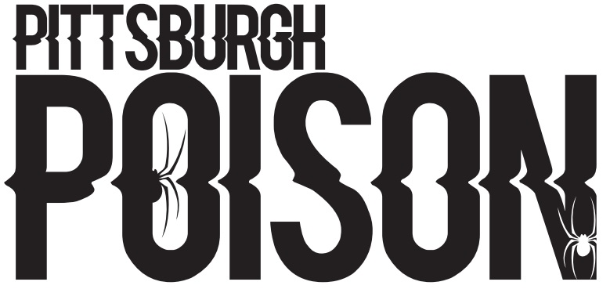
TOXIC
P- Primary Team, S- Secondary Team, SS- Third Team. You must accept your Primary team in order to crossover.

74 | S
75 | S
77 | S
83 | S
86 | S
89 | S
90 | S
91 | SS
92 | S
95 | S
97 | S
99
102 | S
103 | P
104 | P
105
107
108
117 | S
118 | S
120 | S
126 | S
132 | P
135 | S
136
138
139 | P
147
PRACTICE INFO
All teams will practice once/week in the summer. In addition to team practice, athletes will be assigned to a tumbling class, stunt positions class and stretching/conditioning class (skills). During the school year teams will practice twice/week and will have skills. School year schedule will be posted by August 1st.
Summer Practice | Wednesdays 6:00 -7:30pm
Summer Skills | Schedule will be emailed
School Year Practice | Two days/week TBA
Choreography | July 24-29

COMPETITION SCHEDULE
Date | Event | Location
November 12th | Americheer | Dayton, OH
November 19th-20th | Allstar Challenge | Kalahari- Sandusky, OH
December 3rd-4th | WSF | Louisville, KY
December 11th | Elite | Pittsburgh, PA
January 21st | CCC Winter Blast | Erie, PA
February 4th | Aloha | Moon, PA
February 19th | CCC Red Hot | Slippery Rock, PA
March 25th-26th | Cheerpower | Columbus, OH
*This team will compete to earn a bid to the D2 Summit. The D2 Summit will be held May 5-7, 2023 in Orlando, Florida.
TEAM INTRO- Thursday June 16th 7:30pm. Athletes and parents will attend. Athletes wear practice wear. If time permits, we will practice.

June Tuition- $100 due at team intro. Crossovers do not pay extra in June. Cash or check only.

Summer practice schedule will begin June 20th.

