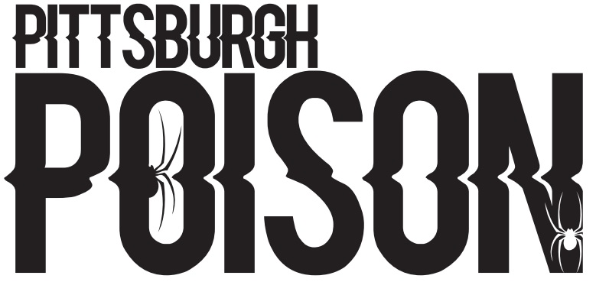
CYANIDE
35 | P
36 | P
37
40 | S
41
43
44
45
46 | SS
47 | P
48 | P
50
52 | S
53 | S
54 | S
55 | SS
57 | SS
58 | SS
59 | S
60
62
63 | SS
64 | P
65 | SS
67 | SS
68
69 | P
72 | S
202 | S
203
P- Primary Team, S- Secondary Team, SS- Third Team. You must accept your Primary team in order to crossover.

PRACTICE INFO
All teams will practice once/week in the summer. In addition to team practice, athletes will be assigned to a tumbling class, tricks class and stretching/conditioning class (skills). During the school year teams will practice twice/week and will have skills. School year schedule will be posted by August 1st.
Summer Practice | Thursdays 8:00-9:30pm
Summer Skills | Schedule will be emailed
School Year Practice | Two days/week TBA
Choreography | August- dates tba

COMPETITION SCHEDULE
Date | Event | Location
November 12th | Americheer | Dayton, OH
December 3rd-4th | WSF | Louisville, KY
December 11th | Elite | Pittsburgh, PA
January 22nd | CCC Hard Rockin Nationals | Erie, PA
February 19th | CCC Red Hot | Slippery Rock, PA
March 4th-5th | Stage 8 | Nashville, TN
March 18th-19th | CSG Dance Grand Nationals | Schaumberg, IL
April 1st-2nd | Dance 1st | Dayton, OH

*This team will compete to earn a bid to the Dance Worlds. The Dance Worlds will be held April 22-24, 2023 in Orlando, Florida.
TEAM INTRO- Wednesday June 15th 6:30pm. Athletes and parents will attend. Athletes wear practice wear. If time permits, we will practice.

June Tuition- $100 due at team intro. Crossovers do not pay extra in June. Cash or check only.

Summer practice schedule will begin June 20th.

