P0

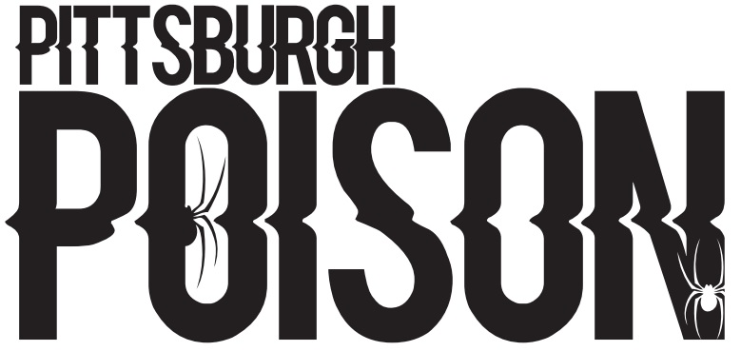
22-23 TUITION
Team | Age | Price | Team | Age | Price
Tiny Cheer | 2015-2017 | $80 | Tiny Hip Hop | 2015-2018 | $80
Mini Cheer | 2013-2016 | $120 | Mini Hip Hop | 2012-2017 | $120
Youth Cheer | 2010-2016 | $120 | Youth Hip Hop | 2009-2014 | $120
Junior Cheer | 2006-2015 | $150 | Junior Hip Hop | 2006-2012 | $200
Senior Cheer | 6/1/2003-2010 | $150 | Senior Hip Hop | 6/1/2003-2010 | $200

*June tuition will be as follows: Tiny/Mini $50, Youth/Junior Senior $100. *Crossovers will not pay extra in June. However, Mini-Jr crossovers will pay the higher price. *During the regular season, crossovers will pay an additional $25/team for tuition.

ADDITIONAL EXPENSES
 | Tiny/Mini Cheer | Yth/Jr/Sr Cheer | Tiny/Mini/Yth HH | Senior Hip Hop
Music/choreography | $250 | $350 | $250 | $550
Competition Fees | $500/900 | $900 | $650 | $800
Skills Clinic | $60 | $60 | $60 | $60
Shoes/Hair/Bow | $180 | $180 | $30-$100 | $30-$100
Uniform | $400 | $400 | $100 | $150
USASF Fee | $50 | $50 | $50 | $50
Lipstick/glitter | $20 | $20 | $20 | $20
Registration Fee | $50 | $50 | $50 | $50
Gym Fee | $100 | $100 | $100 | $100

*All fees are tentative. Exact pricing coming soon
*Fees are split up throughout the season. You will receive a full payment schedule within the next few weeks.
*Crossovers pay full price for music/choreography. Crossovers pay full price for comp fees for first cheer and first dance team. There will be a crossover discount for additional cheer/dance teams.
*Cheer Uniforms will be the same as last year. Returning members will only need to purchase a new uniform if they have outgrown it. There may be some discounted used uniforms for sale. We plan to use our current uniform for the 22-23 and 23-24 seasons.
*Dance teams will get new uniforms every year.

