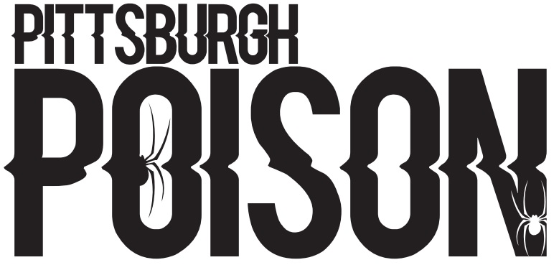
MINIS
P- Primary Team, S- Secondary Team, SS- Third Team. You must accept your Primary team in order to crossover.

2 | P
4 | P
6
7
8 | P
9 | P
10 | P
15
19
20
21
22
23 | P
25
26 | P
28 | P
29 | P
31
33
34
76

PRACTICE INFO
All teams will practice once/week in the summer. In addition to team practice, athletes will be assigned to a tumbling class, tricks class and stretching/conditioning class (skills). During the school year teams will practice twice/week and will have skills. School year schedule will be posted by August 1st.
Summer Practice | Mondays 6:30-7:30pm
Summer Skills | Schedule will be emailed
School Year Practice | Two days/week TBA
Choreography | August- dates tba

COMPETITION SCHEDULE
Date | Event | Location
November 12th | Americheer | Dayton, OH
December 3rd-4th | WSF | Louisville, KY
December 11th | Elite | Pittsburgh, PA
January 22nd | CCC Hard Rockin Nationals | Erie, PA
February 18th | CCC Red Hot | Slippery Rock, PA
March 4th-5th | Stage 8 | Nashville, TN
April 1st-2nd | Dance 1st | Dayton, OH

TEAM INTRO- Thursday June 16th 6:00pm. Athletes and parents will attend. Athletes wear practice wear. If time permits, we will practice.

June Tuition- $50 due at team intro. Crossovers do not pay extra in June (if you crossover to a jr/sr team you will pay the higher price). Cash or check only.

Summer practice schedule will begin June 20th.

