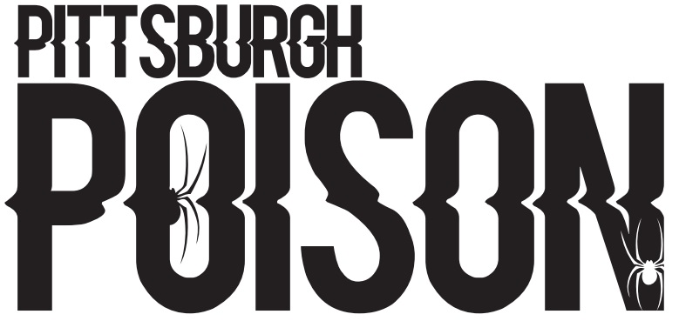
ITSY BITSIES- TINY HIP HOP
1
2
5
6
8
10
12
13
14
15
17
100
102
108

PRACTICE INFO
Summer Practice | Wednesdays 5:00-5:45pm
Summer Skills | Tuesdays- see skills list for times
School Year Practice | One day/week TBA
School Year Skills | One day/week TBA- may or may not be the same day as team practice
Choreography | August 14-17- times TBA

COMPETITION SCHEDULE
Date | Event | location
November 20th | Jamfest | Kalahari, Sandusky, OH
December 11th or 12th | Elite’s Battle in the Burgh | Pittsburgh, PA
January 23rd | CCC Hard Rockin Nationals | Erie, PA
January 29th and 30th | Athletic Championships | Columbus, OH
March12th and 13th | Encore | California, PA

TEAM INTRO- Tuesday June 15th 6:00pm. Athletes and parents should attend!

