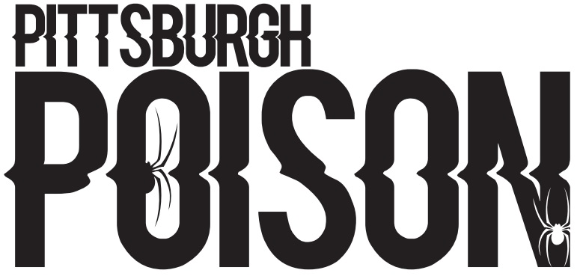
VENOM-SENIOR LEVEL 4 CHEER
19
20
21
25
27
29
31
32
37
38
42
51
52
53
111
112
113
114
115
116
117
118
121

PRACTICE INFO
Summer Practice | Thursdays 8:30-10:00pm
Summer Skills | Tuesdays- see skills list for times
School Year Practice | Two days/week TBA
School Year Skills | One day/week TBA- may or may not be the same day as team practice
Choreography | August 18-20- times TBA
Stunt Choreography | August 28-29- times TBA

COMPETITION SCHEDULE
date | event | location
November 20th | Jamfest | Kalahari
December 11th or 12th | Elite’s Battle in the Burgh | Pittsburgh
January 15th and 16th | American Championships | Baltimore
January 29th and 30th | Athletic Championships | Columbus
February 20th | CSG | Canton
March12th and 13th | Encore | California Pa
April 2nd and 3rd | Spirit Sports | Pittsburgh
May 6th-8th | D2 Summit | Orlando

*This team will compete to earn a bid to the D2 Summit. D2 Summit is listed on the schedule but is pending qualification.

TEAM INTRO- Monday June 14th 6:30pm. Athletes and parents should attend!

